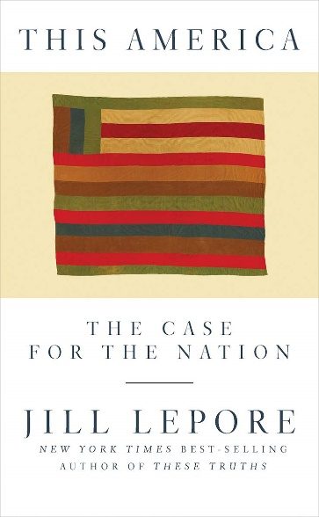

[Region/Class] Princeton Pre-Read Event
[Date]

Read and discuss the short book assigned to all incoming freshmen,
with video of the discussion with the author and students. “In a world made up of nations, there is no more powerful way to fight the forces of prejudice, intolerance, and injustice than by dedication to equality, citizenship, and equal rights, as guaranteed by a nation of laws.”

Our quest to bring the intellectual life of the University to the [Region/Class] continues, with our annual Princeton Pre-Read event. Join us to discuss the relationship between patriotism and human rights, and to consider how an honest reckoning with history might affect the nation’s future.

We will read the book assigned by Princeton’s President Eisgruber this year to all incoming freshmen; and then gather to watch video of the discussion, interspersed with our own discussion of the book.

The Princeton Pre-Read selection for the Class of 2024 is This America: The Case for the Nation by Jill Lepore, the David Woods Kemper ’41 Professor of American History at Harvard University. It explores the idea of the nation and asks how Americans, and the people of other nations, can see themselves as united by a shared commitment to genuinely inclusive ideals despite differences and disagreements that might pull them apart.

Watch President Eisgruber’s video intro, on YouTube, here: https://www.youtube.com/watch?v=6rc2bGNzSkI

The Pre-Read is an annual book club, programmed and hosted by Princeton’s president, that we can all join.

Date and time:

Location:

Registration:

